Coca-Cola
Student’s Name
Institutional Affiliation

Coca-Cola
Part 1
Facebook
Coca-Cola uses Facebook for intensive marketing campaigns in a bid to stay ahead in the highly competitive soft-drinks industry. The company has approximately 102 million followers on Facebook (Pratap, 2018). The company uses this social media platform to create a strong brand image. The company uses celebrities affiliated to various countries when advertising for a particular nation. In this regard, Coca-Cola can identify with these celebrities better; thus, creating emotions that can lead to strong brand loyalty. I am opined that the social media platform’s primary objective is to remind existing Coca-Cola customers to continue consuming its products. The company can engage with its customers effectively within this platform. Thus, it addresses customer complaints effectively.
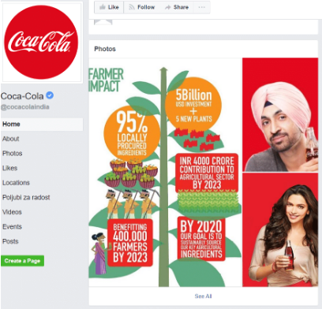
Fig 1 shows Coca-Colas campaign using celebrities to market its products on Facebook
Twitter
Coca-Cola has 3.31 followers on Twitter. The social media platform helps the company advertise its products to reach a broader market reach. The social media platform helps Coca-Cola to use pictures and videos to showcase its marketing campaigns (Pratap, 2018). Also, the social media platform helps influence customer behavior since the videos play automatically as the users scroll through their news feeds. The videos and images are always appealing to create an optimal viewing experience. I think that Coca-Cola uses Twitter to inform its customers about its products with regard to new features, offers, and discounts. For instance, Coca-Cola can use Twitter to inform its customers that movies are enjoyable when watched while drinking Coca-Cola.
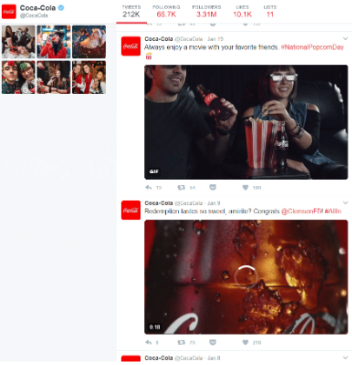
Fig 1 shows Coca-Cola using Twitter to inform customers that an optimal movie experience is accompanied by Coca-Cola products.
Instagram
Coca-Cola uses Instagram to display photos and videos about its product. Notably, the company uses the social media platform by mobilizing Instagram influencers to reach micro-demographics. The influencers are supposed to create sponsored posts that highlight various Coca-Cola products. The sponsored posts have hashtags that are used to build narratives on how Coca-Cola has helped them in their causes as influencers. For instance, it created a campaign dabbed “This one is for Instagram” that managed to garner 173,000 likes as well as 1600 comments (Media Kix, 2020). I am opined that the company uses Instagram to persuade customers to make purchases.

Fi 2 shows Coca-Cola’s campaign “This Ones For Instagram”
YouTube
Coca Cola uses YouTube to advertise its products using video creations that carry campaign messages aimed at improving sales. Coca-Cola uses videos capturing persons enjoying various moments of their life drinking Coca-Cola products. The videos aim at creating the “feel good” factor and portray a lifestyle of happiness. Using YouTube as a promotional channel targets the millennial generation that has an affinity for video content. I am opined that the social media platform is used to connect better with the customers; therefore, its primary aim is to persuade potential customers to buy Coca-Cola products. For instance, YouTube has 5421 videos on Coca-Cola campaigns that are made in different languages. One notable video was the “Taste the Feeling” video that captured youth festivals to depict an energetic generation that enjoys drinking Coca-Cola drinks.
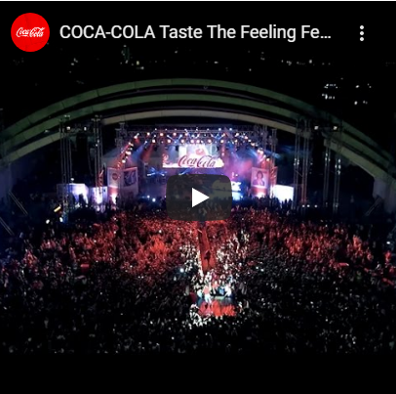
Fig 3 shows the “Taste the Feeling’ video that was uploaded in 2016
Part II
The social media strategy for Coca-Cola is appealing and well-integrated. The company uses various campaigns that are theme-oriented. Therefore, these campaigns are appropriate to the social media audience that has a high affinity for interactive digital content. Coca-Cola uses these social media platforms to create optimism, uplift, and connect with potential customers. The images and the videos that the company uses for its campaigns are relevant; thus, creating strong brand awareness. Besides, the company uses the social media approach to propagate its core values. Notably, using celebrities and social influencers in their campaigns helps the company connect better with their customized.
Moreover, the promotional campaigns fit with the brand image and values since they aim at creating optimal customer satisfaction. For instance, the company's marketing strategy to personalize Coca-Cola bottles by including various names of the customers was aligned with its concept of happiness (Cole, 2019). Customers would go to stores and look for bottles that have their names on them. The campaign resonated well with the customers' needs. Besides, the campaigns reflect Coca-Cola's image of love by using love themes on its bottles as well as deploying advertising participants that depicted love. Lastly, the campaigns portrayed the feeling of greatness that epitomizes Coca-Cola's core values. In this regard, the social media campaigns aimed at showing customers that they will be empowered by drinking Coca-Cola products.
Overall, I am opined that Coca-Cola's social media strategy is successful since the company has been able to persuade, inform, and remind customers to purchase their products through creative and innovative campaigns. Thereby, the company has been able to engage with its customers effectively and create a strong brand image in these social media platforms. Besides, the campaigns are takeover-oriented since they aim at working with third parties that customers identify with effectively (Cole, 2019). Lastly, Coca-Cola's campaigns are successful in capturing major events such as Christmas; therefore, showing customers that it will always be with them during their most memorable moments.
Moreover, the company's website also works perfectly since it has an excellent user interface that enables customers to access information about Coca-Cola products. The website has appealing images of people and its products with attractive campaign messages—also, the website display written and pictorial content on their brands, promotions, and offers.
Part III
The overall aim of social media platforms is to inform, persuade, and remind since they have features that enable Coca-Cola to customize their campaigns based on their promotional needs. For instance, Coca-Cola uses Instagram and Youtube to persuade its customers to purchase it products. Also, it used Facebook to remind and Twitter to inform its customers. However, there is too much redundancy in these social media platforms. In this regard, it is common for Coca-Cola to run most of its campaigns throughout all the social media platforms. Most of the users that Coca-Cola target are likely to be on most of these social sites; therefore, posting the same campaigns leads to redundancy. Thus, one social media platform can be removed without risks of loss.
In addition, social media campaigns are majorly geared toward existing customers. Most of Coca Cola's customers are social media users. Therefore, Coca-Cola uses these social media platforms to persuade, remind, and inform them about their products. Besides, these social sites are used to create strong brand images that aim at creating customer loyalty. Notably, communication in social media platforms is interactive. Social media platforms have comments sections that enable customers to interact with Coca-Cola on its pages and websites. Thus, customers can give their feedback as well as submit complaints regarding Coca-Cola's products.

References
Cole, S. (2019). Three keys to Coca-Cola’s success on social media. Econsultancy. Retrieved
from https://econsultancy.com/coca-cola-social-media-success-case-study/
Media Kix. (2020). Coca-Cola’s marketing strategy: How the beverage giant raises brand
Awareness with influencers. Retrieved from https://mediakix.com/blog/coca-cola-marketing-strategy-influencers-ambassadors/
Pratap, A. (2019). Social media for marketing: The case of Coca-Cola. Notesmatic. Retrieved
from https://notesmatic.com/2017/01/coca-cola-social-media-marketing/

